Implementation in Power BI
To understand the analysis of any particular business, product, department, or project the dashboards are used as the very easiest type of visual implementation of data. Not only for getting appropriate results but also to deliver a detailed idea about the data the dashboards are useful. For this motive, we have used the power BI tool for better visualization and reasoning. It is mainly used as a business analytics tool powered by Microsoft. The dashboard below represents the revenue analysis of flights.

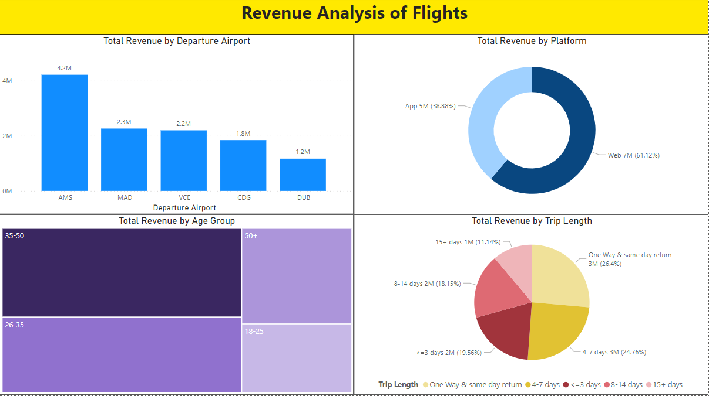
Figure 1: Dashboard 1 revenue analysis of flights
As shown in figure 1, demonstrates the revenue analysis of flights including total revenue of the departure airport, total revenue of the platform, total revenue of trip length, and total revenue by age group. Where the total revenue of departure airport consists of a list of the airports in which
- AWS- Amsterdam
- MAD- Madrid
- VCE- Venice
- CDG- Paris
- DUB- Dublin.
In total revenue of platforms, platform 1 is a web which is 61.12% and platform 2 is an app which is 38.88%. Similarly, the total revenue by trip length has one day and same-day return trip, 4-7 days trip, less than or equal to 3 days trip, 8 -14 days trip, and 15 plus days trip length data is presented. Total revenue of age groups has 35 to50, 50 plus, 26 to 35, and 18 to 25 years of age revenue are visualized.
The next dashboard illustrates the customer profile analysis as shown in figure 2.

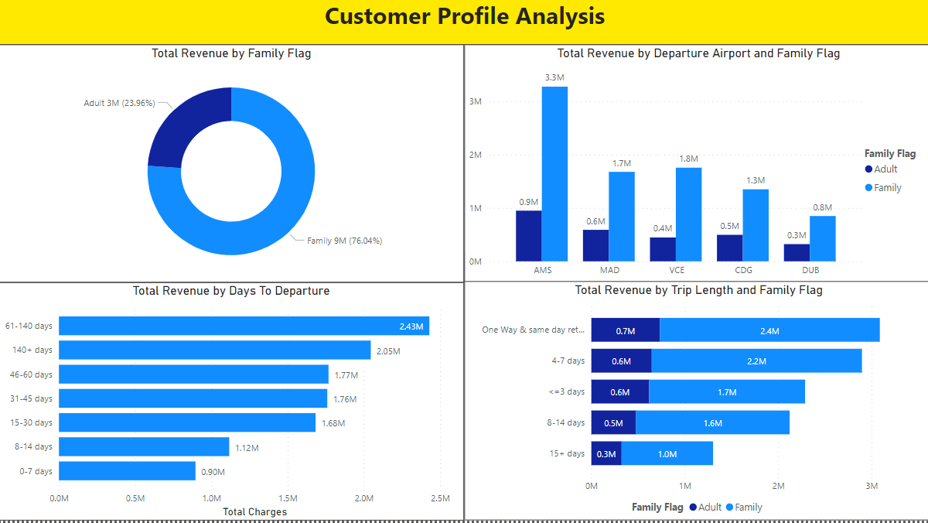
Figure 2: customer profile analysis (dashboard 2)

The customer profile analysis consists of total revenue by the family flag, total revenue by the departure airport and family flag, total revenue by trip length and family flag, and total revenue by days to departure. In dashboard 1 the revenue analysis was done for the flights whereas in this dashboard the factors related to the customer profile is been analyzed. The family flag has two attributes adult and the entire family. Departure airport and the family flag have the revenue records of each airport among the five and as stated the family flag has adult and family. The total revenue by trip length and the family flag has the relationship of trip length and family flag in which the one way and same-day return trip has the highest revenue of 0.7M for adults and 2.4M for family. The fourth graph consists of days to departure revenue in which the 0 to 7 days trip has the lowest 0.90M whereas 61 to 140 days has 2.43M of total charges.

The third dashboard is about the product revenue analysis.
The third dashboard covers product revenue in which the products are seats, 20kg bags, and 10kg bags to which the 20kg bag has the highest revenue of 57.97%. Product revenue by family category where the family category has the highest revenue of 0.42M. The age products revenue for age 26 to 35 age has 20kg bag length. For the product revenue by the airport, Amsterdam has the highest revenue of 111k for 20kg bags and the Paris airport has the lowest of 60k respectively.
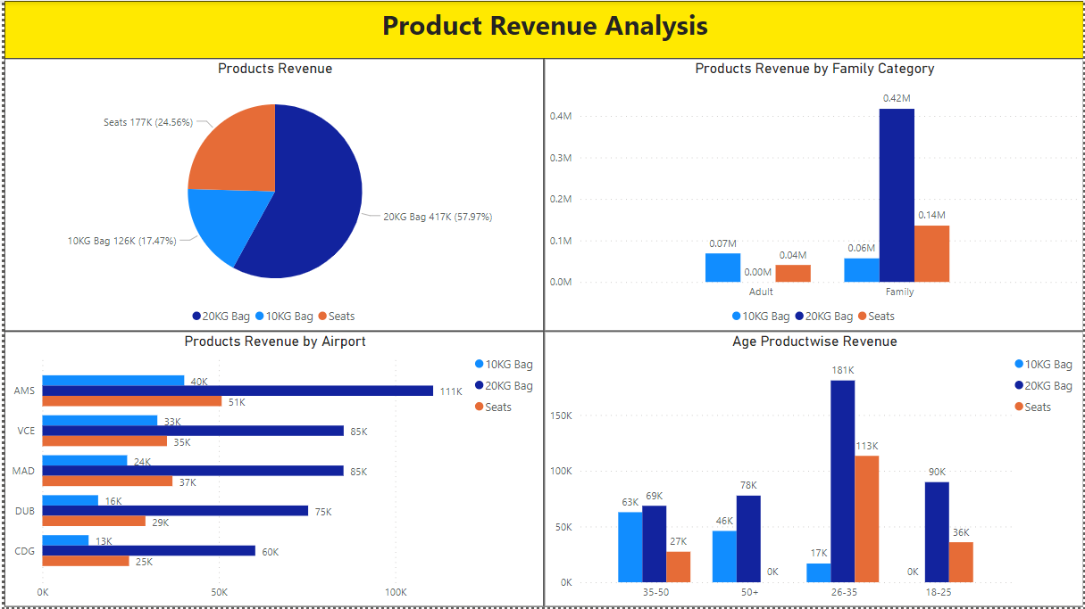
Figure 3: Product Revenue Analysis. (Dashboard 3)

Teamwork:
There are 3 members in our group. We mutually decided to work on an airline company that concentrates on a fair price as well as services provided by the company. From creating the own dataset in excel to implementing the dashboard all work was done in an equally distributed manner. The work done on this project is as follows:

All the group members worked equally on this project area are as follows:
- Implementation of dynamics CRM: Nishant Ajaychand Bharti.
- Creating a database and creation on dashboards using power BI: Chinmay Laxmikant Mukim
- Data structure design and data management with the representation of the details using diagrams: Abhay Singh Bangari.
While working on the project, we had several group meetings where the discussion was done on several factors like planning for the work, designing, details which we included in both the specification and implementation report, and working on all stages with respect to the deadline. After implementing all our assigned parts we merged all the data in this document.

References:
[1]M. Corporation, "Business Applications | Microsoft Dynamics 365", Dynamics.microsoft.com, 2021. [Online]. Available: https://dynamics.microsoft.com/en-ie/. [Accessed: 17- Apr- 2021].

